**Assignment 3 - Computer Vision**

**Hodaya Shalom, Yael Berger**

**Part B – Optical Flow**

Question 4+5 – Testing our algorithm with different parameters

We first fix a sigma and run the algorithm for different size regions. Then we fixed the region size and run the algorithm for different sigma values. Then we fixed sigma and the region and tested the algorithm for different jumps between the frames.These are the results we got for changing each variable individually :

1. *Fixed sigma (2). Different regions-*

|  |  |
| --- | --- |
| /Users/yaelberger/Desktop/ex3/rg5.jpg  Figure 1: region=5x5 | /Users/yaelberger/Desktop/ex3/rg10.jpg  Figure 2: region=10x10 |
| /Users/yaelberger/Desktop/ex3/rg20.jpg  Figure 3: region=20x20 | /Users/yaelberger/Desktop/ex3/rg30.jpg  Figure 4: region=30x30 |
| /Users/yaelberger/Desktop/ex3/rg40.jpg  *Figure 5: region=40x40* | /Users/yaelberger/Desktop/ex3/rg50.jpg  *Figure 6: region=50x50* |

As we see about, as the region size gets bigger, we can notice more motion in the image and the detector is more sensitive to small motions. Let the optimal region size value that maximizes the similarity of the measurement to the actual movement be p. As region size value get bigger than p, the movement measurements are less similar to the actual movement.

1. *Fixed region (30x30). Different sigma values-*

|  |  |
| --- | --- |
| Figure 1: sigma=1 | Figure 2: sigma=3 |
| Figure 3: sigma=6 | Figure 4: sigma=10 |
| *Figure 5:*  *sigma=20* | *Figure 6:*  *sigma=30* |

As we see about, as the sigma smoothing value gets bigger, we can notice that there is less noise and the motion in the image gets more precise. However, for small movement, as smaller the sigma gets, more movement is measured (because for bigger sigma some of the information in the smoothing process gets lost). Let the optimal sigma smoothing value that maximizes the similarity of the measurement to the actual movement be p. As sigma values get bigger than p, the movement measurements are less similar to the actual movement.

1. *Fixed region (20x20) and sigma(2). Different distance between the frames-*

***Successive frames:***

|  |  |
| --- | --- |
| Figure 1: frame=1 | Figure 2: frame=2 |
| Figure 3: frame=3 | Figure 4: frame=4 |
| *Figure 5:*  *frame=5* | *Figure 6:*  *frame=6* |

***Jump of k frames: different distances of frames from the same image***

|  |  |
| --- | --- |
| Figure 1: distance different=0 | Figure 2: distance different =3 |
| Figure 3: distance different =6 | Figure 4: distance different =10 |
| *Figure 5:*  *distance different =20* | *Figure 6:*   *distance different =30* |

As we see about, if we use successive frames to check motions, there is a lot of noise in the movement measures and even some parts of the background (like the road) look moving. However, using a further distance then we get a better result but from some point we lose some movement measurement.

We can see notice that changing the k value (frame difference) greatly depends on the speed of the movement of the object in the image and also on the frame rate. We found that a larger k can be used if the object is moving at a steady pace however if the object changes direction of movement or changes the speed, we must use smaller k value.

Question 6+7 – Testing our algorithm with different frames sizes

***different frames sizes - observations***

|  |  |  |
| --- | --- | --- |
|  | **Small jump - Distance of 2 frames** | **Big jump - Distance of 8 frames** |
| 0.2 |  |  |
| 0.4 |  |  |
| 0.6 |  |  |
| 0.8 |  |  |
| 1 |  |  |

As we see about, if the distance between the images is small - we need a bigger image size to catch the movement than a far distance between the images. In addition as the image size scale gets smaller, we observe more movement in the background and we notice less gentle movement.

We also found that different scales can be used to detect sizes of movement i.e., as we scale the image to a smaller size, the algorithm detects the larger movements and lightly scaling (end result is a larger image) identifies smaller movements. Here we should have also taken in to consideration the ration and sigma which should have been adapted to the scaled image.

b. As we saw in class, we go from a small scale to a large scale – at the small scale we catch the big and rough movement and as the scale get larger we catch more gentle and small movement. Each scale is used as another layer for an interpolation for getting the right and accurate optical flow.

Question 8– Segmantation

See Matlab function **seg_OF_size.m** and **Run3.m: Part 8 - Size segmented image (pair of frames and entire sequence / a part of the sequence)**.

Detects pixels with large optical flow as foreground and low optical flow as background (|M(x,y)|>th). Segments are connected components.

Results on a pair of frames (#1, #3):

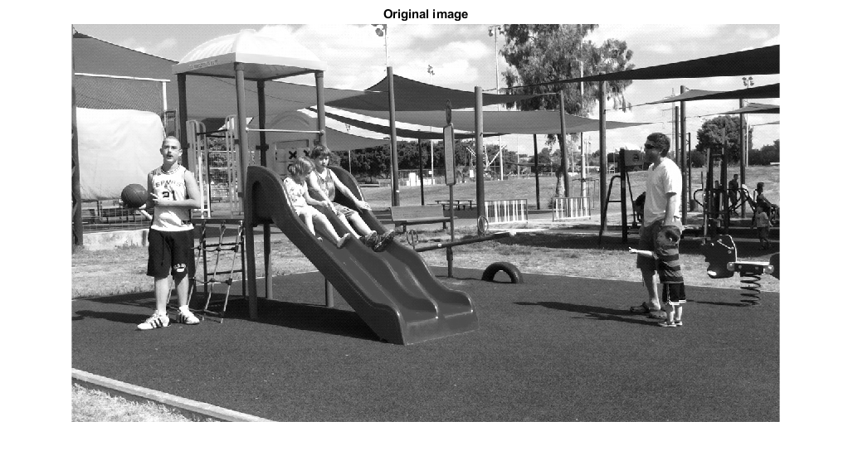

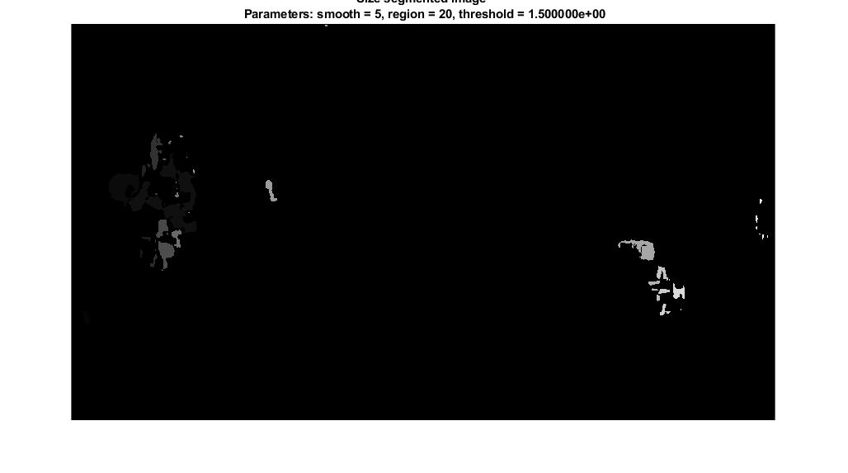

Results on the entire sequence (or a long part of it): We display here only representative frames.

Frames #6-7:

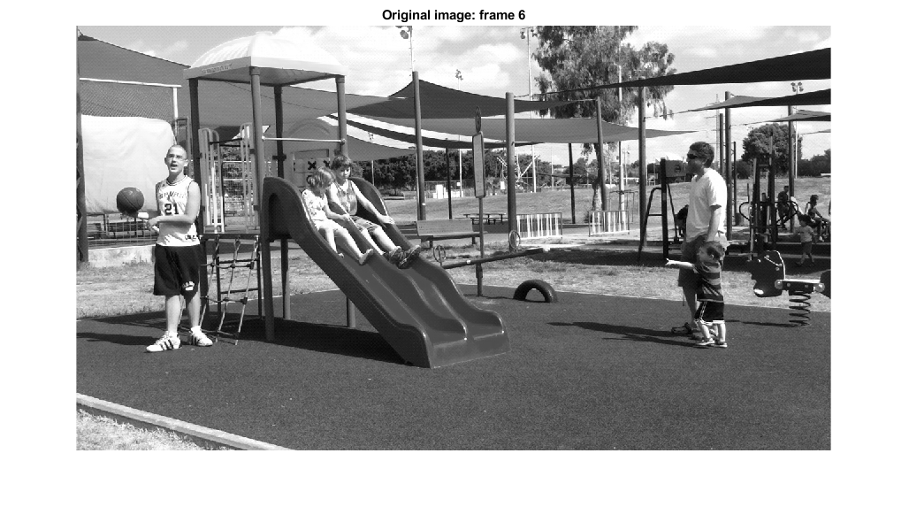

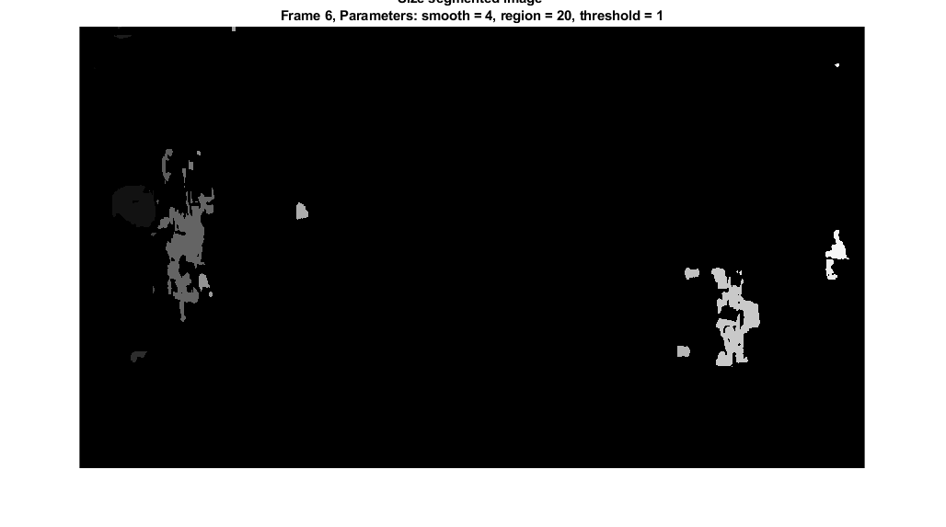

Frames #9-10:

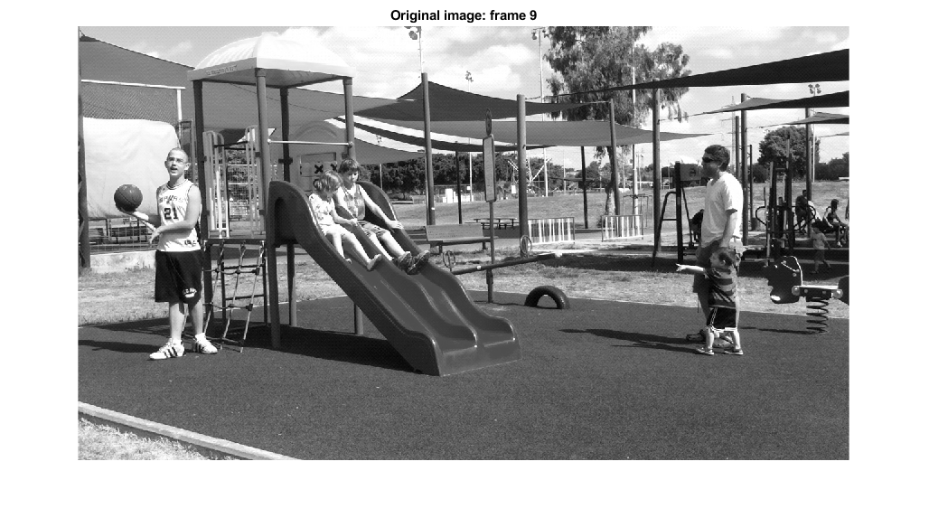

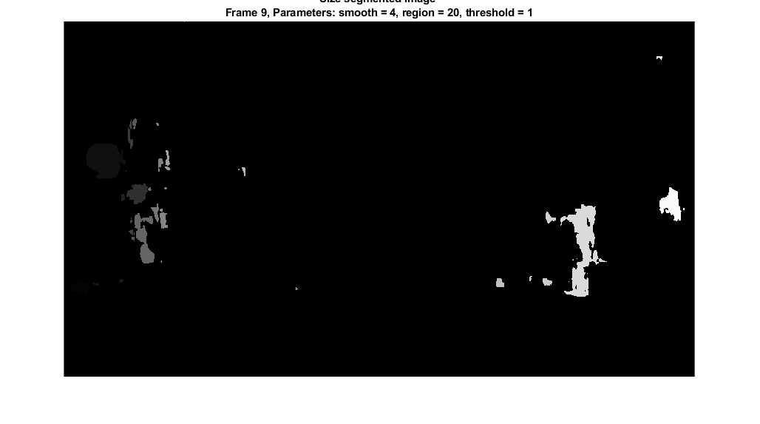

Frames #61-62:

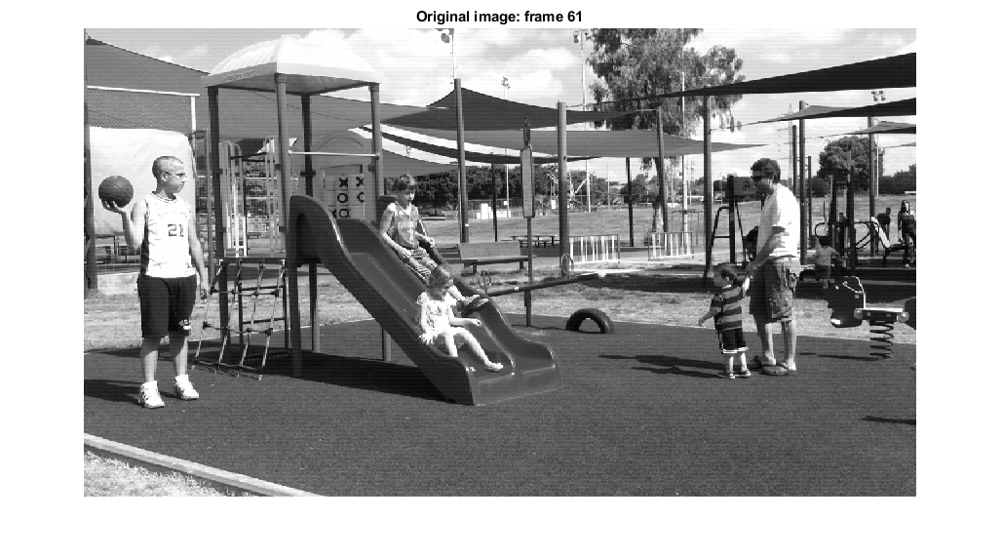

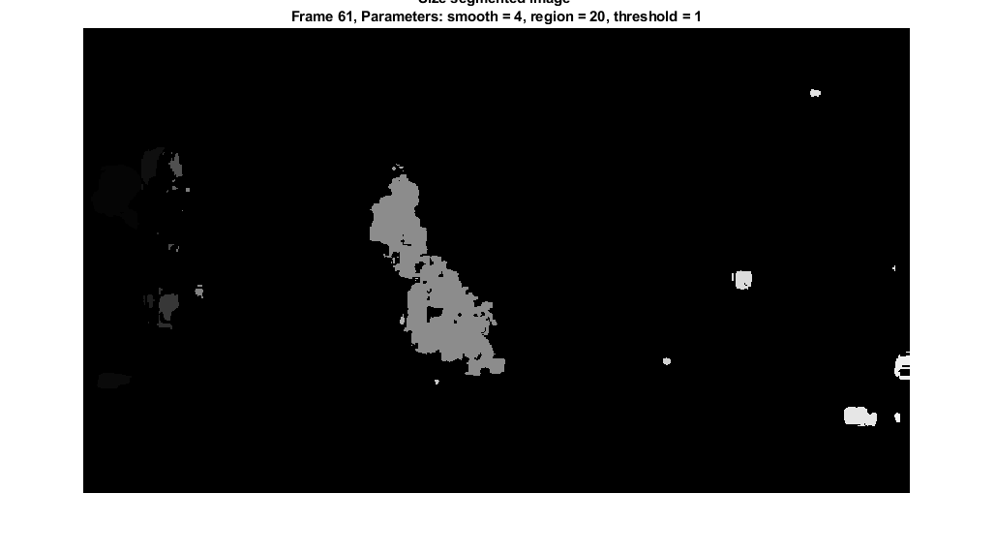

Frames #70-71:

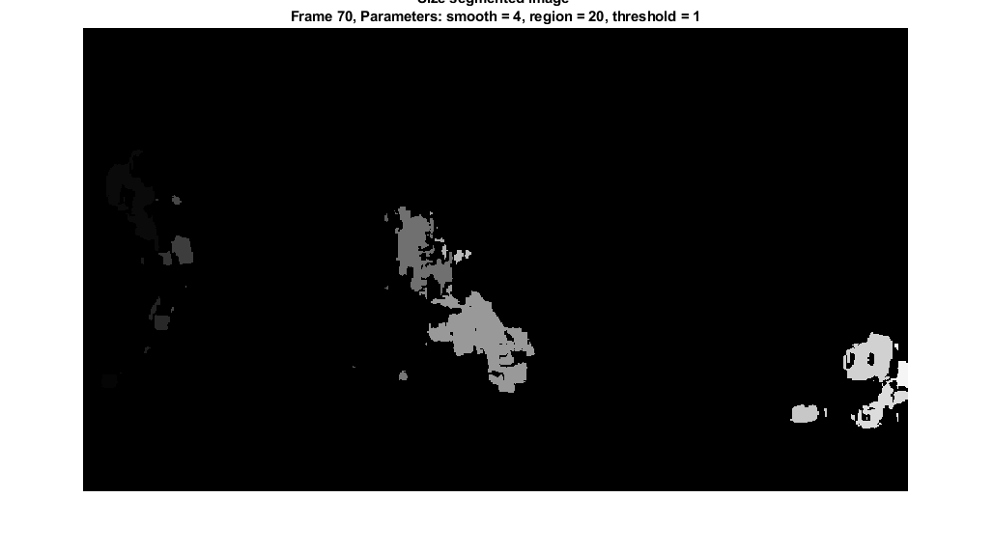

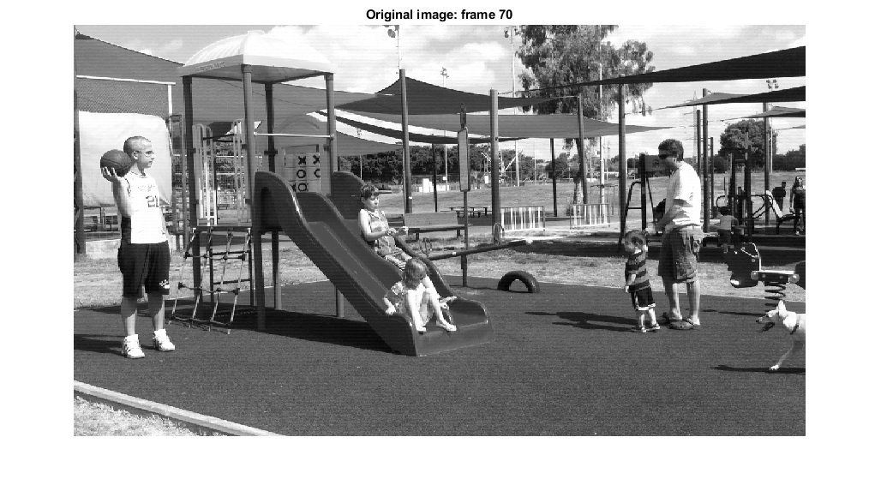

Question 9 – Direction segmented image

9. See Matlab function **seg_OF_direction.m** and **Run3.m: Part 9 - Direction segmented image (pair of frames and entire sequence / a part of the sequence)**.

Detects pixels that move to the same direction, using a set of thresholds on the angles.

We ran the function on people.avi, on a pair of frames and on the entire sequence. We display here only representative frames.

Results on frames #2-3:

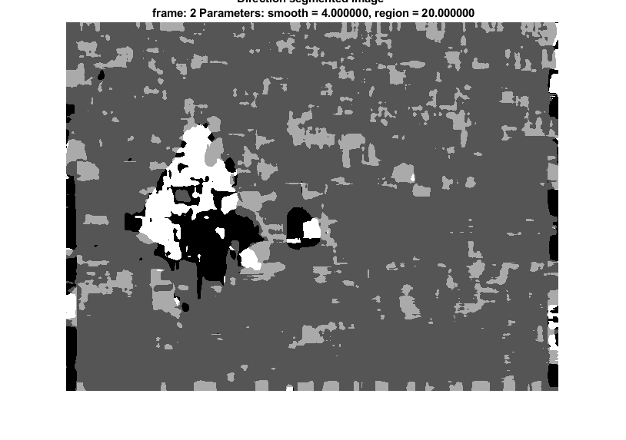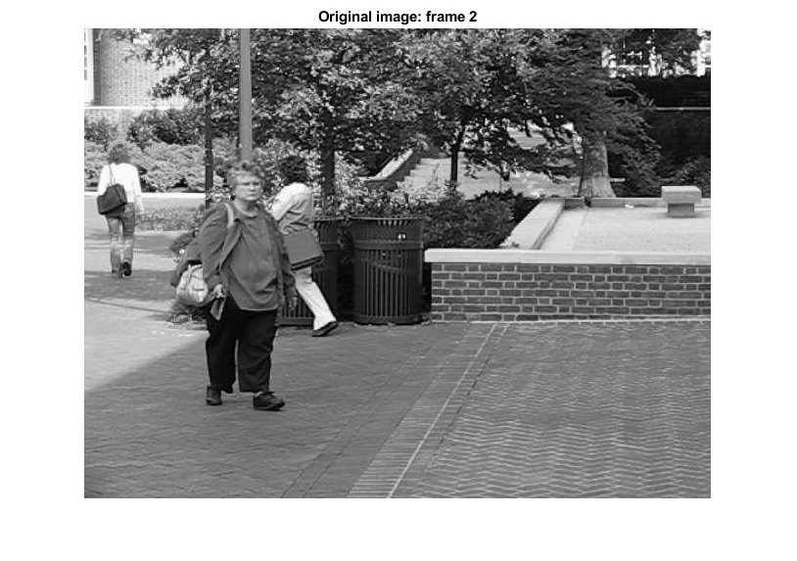

Results on frames #8-9:

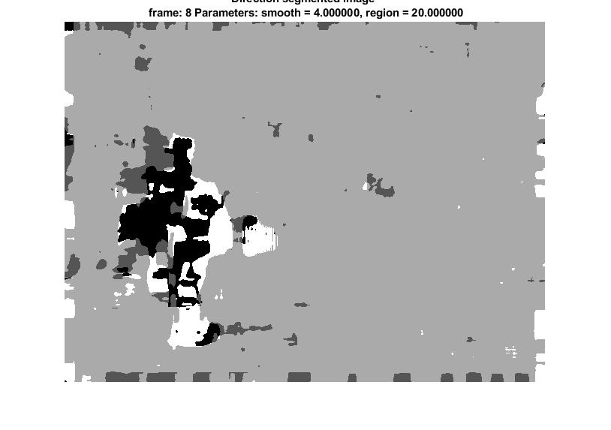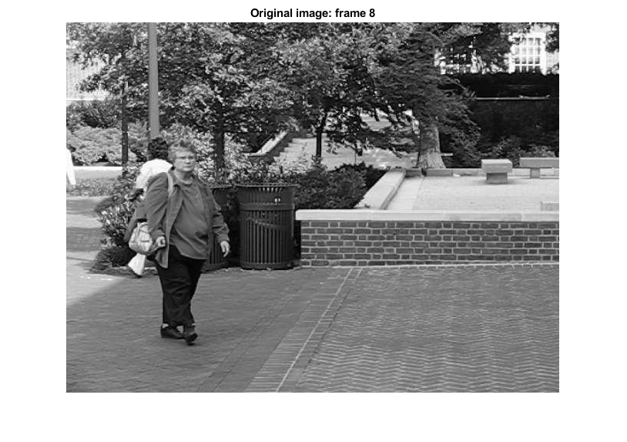

Result on frames #9-10: 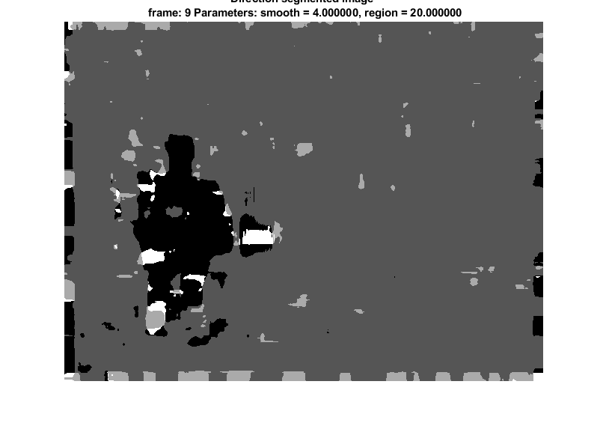

Question 10 – Threshold

Thresholding M or O can be used to define background and foreground regions under the following assumptions:

* The motion of the foreground should be in a different direction than the background, and the movements in the background should be slower / smaller.
* Brightness constancy.
* The camera remains quite still, to prevent noise that could cause the background to be considered as foreground.

**Part C**

1. First we take the corresponding points between every pair of images from the optical flow. Then through RANSAC we take 4 points each time until we find homography denoted by H. All the corresponding points that supply the equation $p_{i}=Hq_{i}$ (where $p_{i},q_{i}$ are corresponding points) are on the ground.

Explanation:

We assume that the ground plane is the only planar surface across all consecutive frames. Because the ground is planar then the homographic transformation $p_{i}=Hq_{i}$ must apply to all the points there for the specific H we found. However all the points that are not on the ground won’t be related by homography H. Therefore we can subtract the ground plane from the rest of the scene.

1. As we did in section a, we will find the homography matrix H. then will check if this matrix is a rotation one (by checking if $H^{T}=H^{-1}$)

Explanation:

A homogrphy matrix takes one point in the first image and finds the corresponding point in the second image. Therefore if there was only rotation, all the points rotated equally and then the homography just took the first point and rotated it so now it will be the corresponding point in the second image.